Key Points:

1. To Save – Ctrl+Shift+S
2. To create a variable – Ctrl+K
3. Main.XAML – Code is written in this file
   1. Numeg – compiles and run the file
4. Work Flow
   1. Sequence
   2. Flow
   3. State
5. Input Methods for Type& Click
   1. Default – Foreground
   2. Send Window – Back ground & accept HotKeys
   3. Simulate Back ground & Don’t accept Hot Keys
6. Output Methods
   1. Screen Scrapping – For simple
   2. F3 – To capture and highlight exact field
      1. Native – ignores Hidden text– Very SLow
      2. Full Text
      3. OCR – Optical Character Recognition – Very slow
   3. Data Scrapping – For larger Data (with similar set of patterns)

WildCards/Dynamic Selector/Locator change:

? - For dynamic selector – when there is one letter changing

\* For dynamic selector – For multiple characters changing

For any element to be identified, ensure title,name & ID

Remove parent id

Indicator anchor – To type based on relative element

Steps:

1. To use chrome, enable extension in home—>extension—>
2. For Type into, to send characters and press ENTER – on selecting “send window” in properties , it can be done.

Method:

To ignore case

string.equals(str1,str2,string comparison.ordinalIgnoreCase)

Conversion

Convert.ToChar(variable)

Wait:

Delay(hh:mm:ss)

On Element Appear – Default wait time 30s

String Methods

1. Variable.split({“;”},stringsplitoptions.None)(index)
2. String.replace
3. String.trim
4. String.remove
5. To store string values in Array
   1. Str.split(Environment.newline.Toarray)
6. To remove empty value while splitting
   1. Str.split(Environment.newline.Toarray,SplitStringOptions.RemoveEmptySpaces)
   2. To remove any additional texts in array – Use Remove or Replace

Recording:

4 types of recording

1. Basic
2. Window
3. Web
4. Citirx

Image Recording – OCR to get data from image

OCR:

Microsoft OCR

Google OCR

AbOCR

Difference between Basic and Desktop

Basic – Creates all activities in one sequence. Only Screen Scrapping available. Doesn’t create multiple windows when working on many windows

Desktop Recording - Creates a separate window/activity

Mail:

1.SMTP

SMTP- Just to send e-mail message

Port Number

Server Name

To

Attach Files”exact path”

2.IMAP – To read files and perform some action

Folder name – Inbox

Multiple name – Inbox/favorites

OnlyReadMessage – Check box

\*To read all e-mails

1. Get IMPA mail message
2. How many e-mails/Read or UnRead
3. Mail Message are stored under under List<mailmessage>
4. Under each List , all details of one email is stored
5. To iterate e-mails, use For Each
6. In For Each, default variable “Item” is created
7. Format of Mail Message – Type/Arugment should be System.Net.Mail.MailMessage

All mail message will be stored in Item variable

To Read values use Item.Subject or Item.body etc

\*To Save e-mails and move it to a different folder

Syntax to Verify if e-mail has attachments

Item.attachement.any – It return true or false.

Item is the variable in for each

To Save attachement or move e-mail Use the variable “Item” inside the For loop. As moving and saving requires mail message format.

List,Array & Dictionary:

To add list

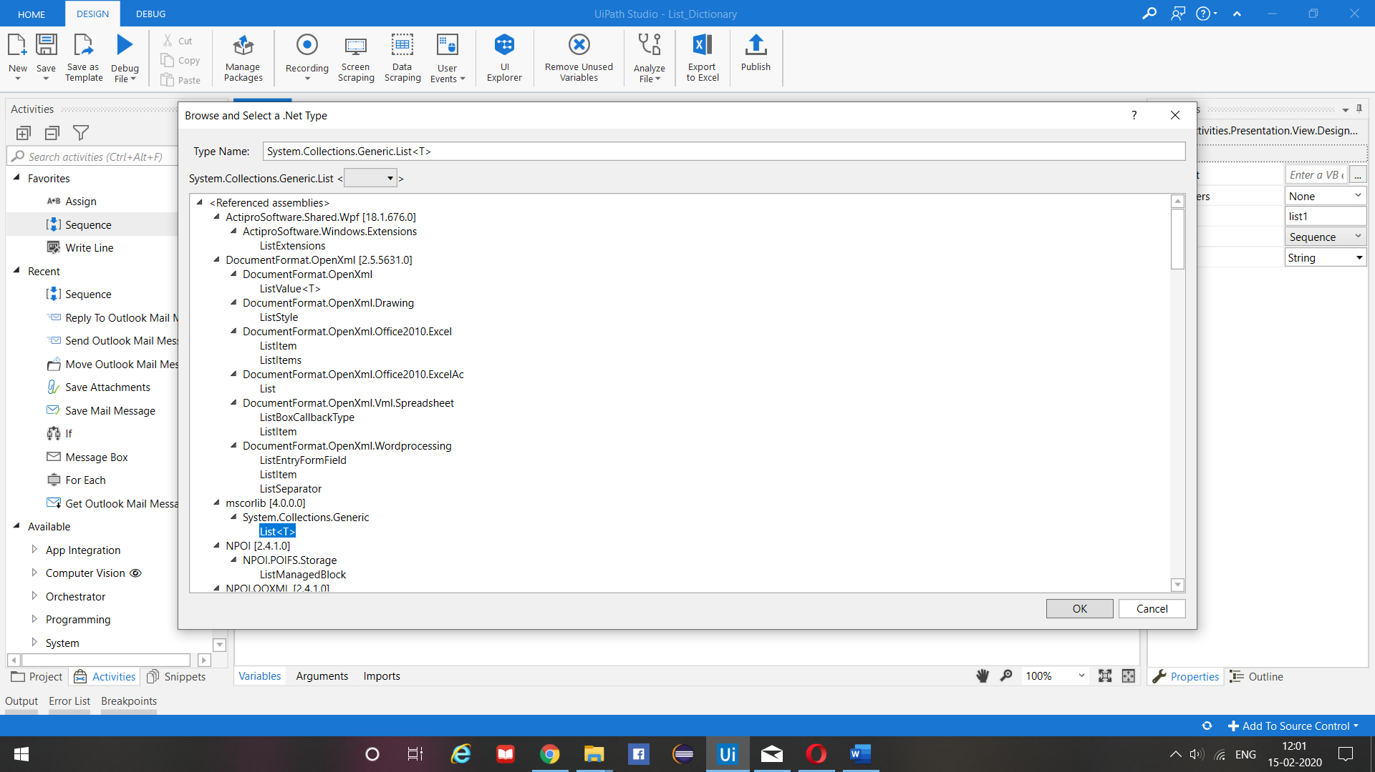

Invoke Method:

Target Object = List name

Parameter = Mention the direction and value

Method Name = Add, Remove or Replace

Dictionary:

Key Value Pair Concept